

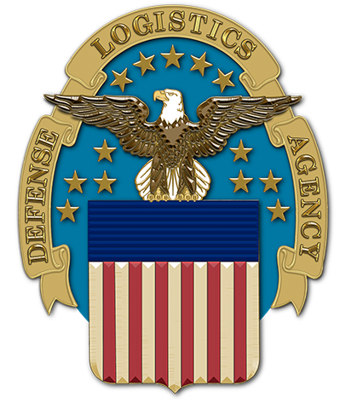

**Gaylord National Hotel and**

**Convention Center**

**National Harbor, Maryland**

**2022 DLA Energy**

**Worldwide Energy Conference**

**March 28-30, 2022**



CALL FOR PAPERS

2022 DLA ENERGY WORLDWIDE ENERGY CONFERENCE

**Please complete blue highlighted areas below.**

**TITLE**

# KEYWORDS

Include keywords here, separated by commas; include five keywords.

# ABSTRACT

Include a 200-300 word abstract here, providing enough detail to determine the nature of the topic and how it benefits the energy supply chain or DoD energy operations.

----

# ABOUT THE PRESENTERS

**Main Presenter Name:**

**Contact information**:

**Biography**:

**Second Presenter Name (optional)**

**Contact information**:

**Biography**: